**1.4.1:**

**Does your university as a body provide assistance in the local community supporting the start-up of financially and socially sustainable businesses through relevant education or resources? (e.g. mentorship programmes, training workshops, access to university facilities)?**

**A N S W E R:**

Alkafeel University actively supports the local community by providing financial assistance and resources to encourage the creation of financially and socially sustainable businesses. The university recognizes the importance of economic development and community empowerment, and has initiated various programs to support local entrepreneurs. The key aspects of this support include:

* **Job Fair:** Individuals from inside or outside the university can showcase their products for free, giving them opportunities to gain work experience without any cost. This is especially beneficial for those who are new and seeking to build their expertise.

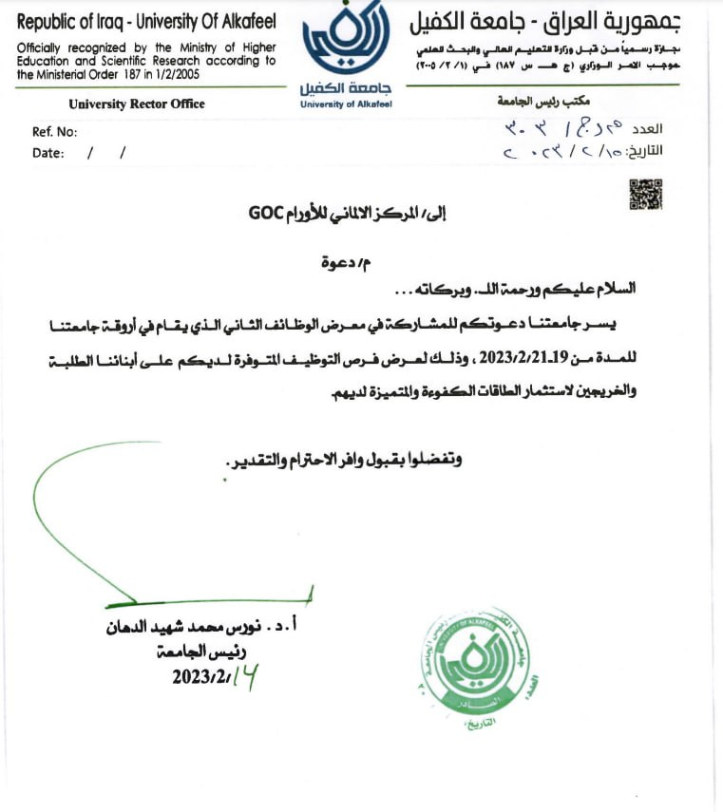

Invitation to participate in the Job Fair organized by our university.

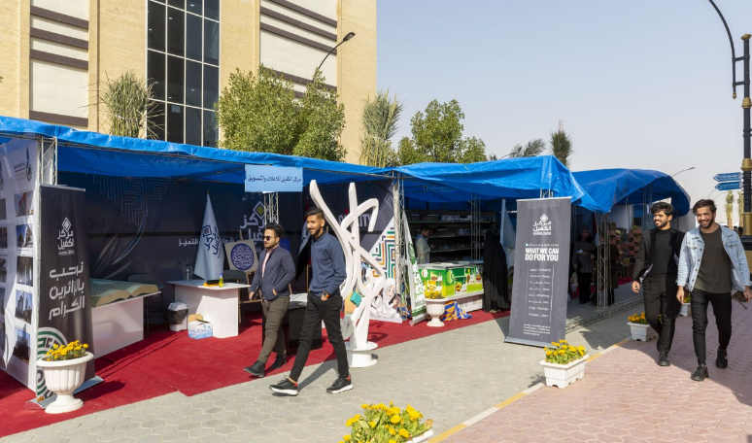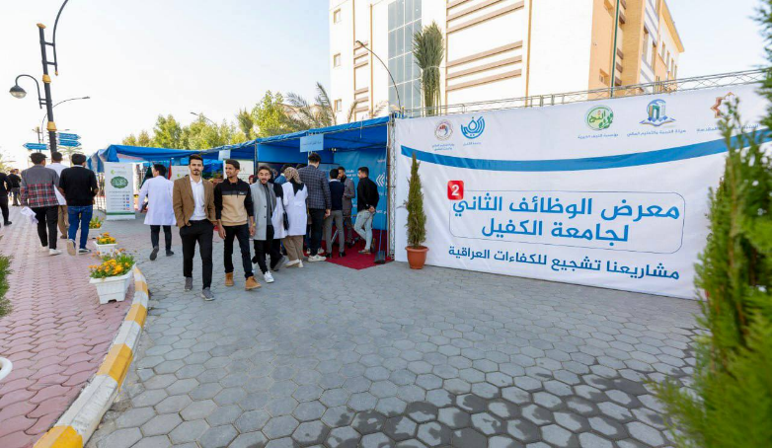

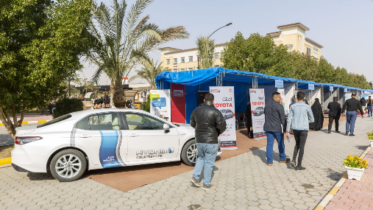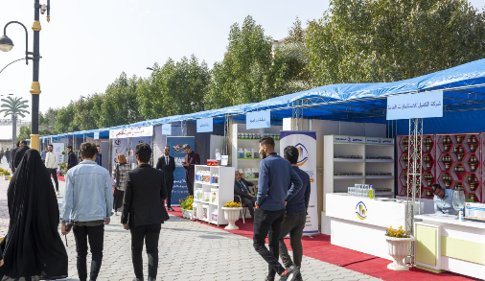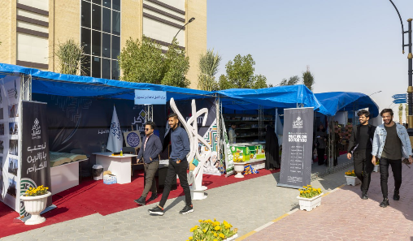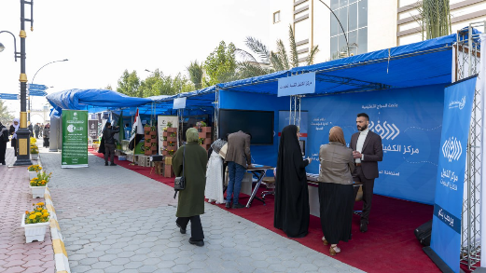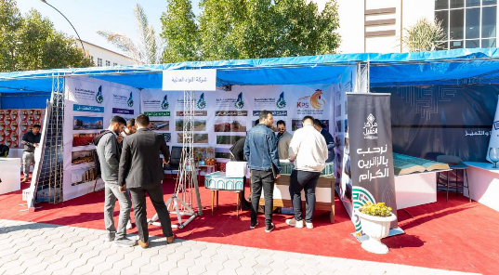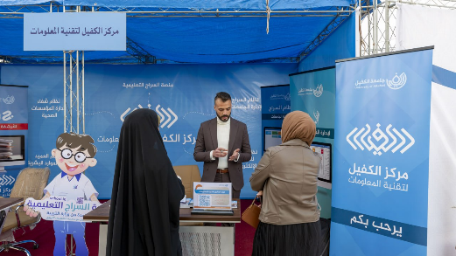

**Job Fair**

* **International Conference:** Emerging companies and researchers can present their research or projects, and if deemed valuable, they receive financial rewards.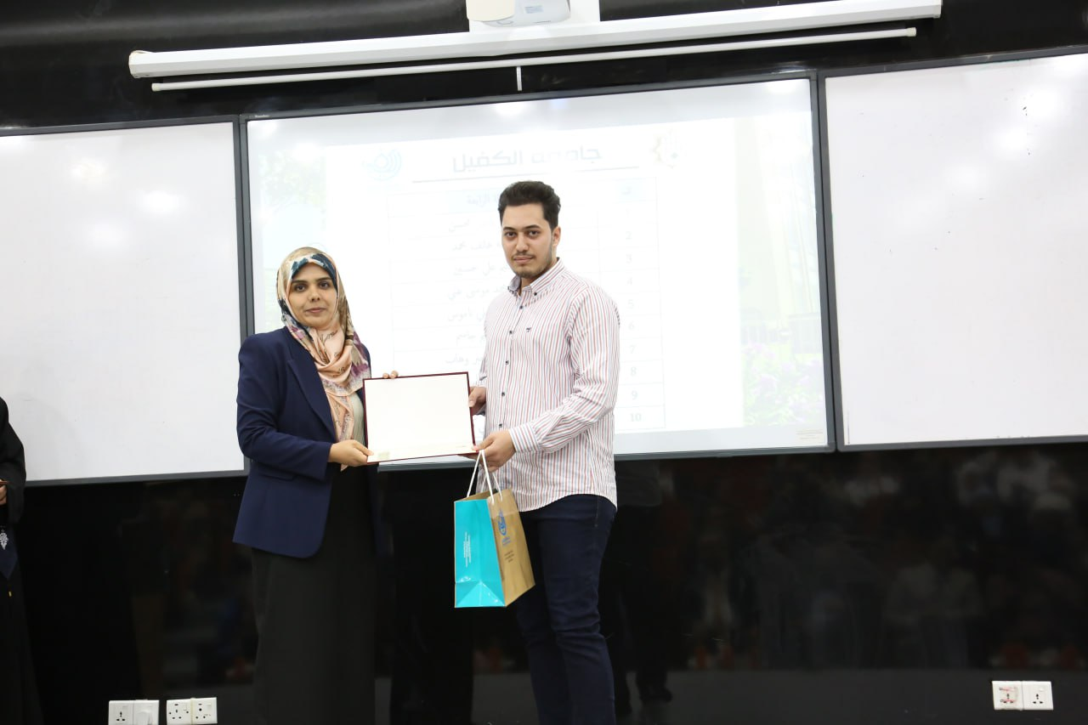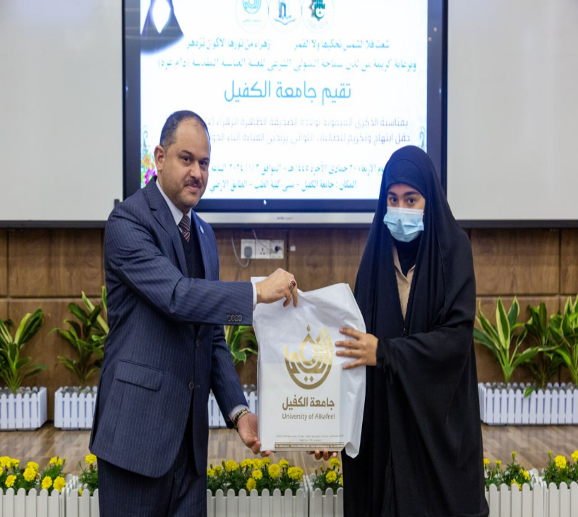

[**https://alkafeel.edu.iq/news/details/1003**](https://alkafeel.edu.iq/news/details/1003)

[**https://alkafeel.edu.iq/iscku2022/**](https://alkafeel.edu.iq/iscku2022/)

* To further support the development of local businesses, Alkafeel University collaborates with financial institutions to facilitate access to loans and other financial resources for entrepreneurs. This partnership ensures that startups receive the necessary financial support to sustain and grow their businesses.

Bellow some of the official books for community service:

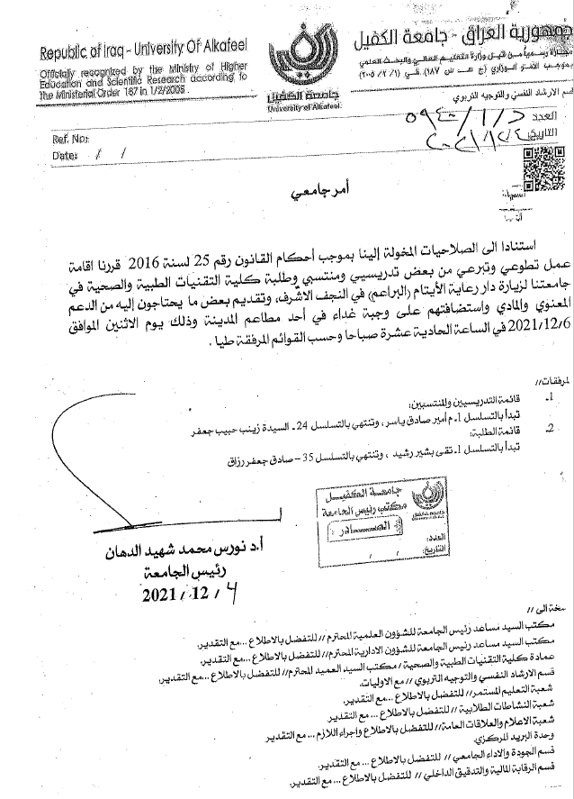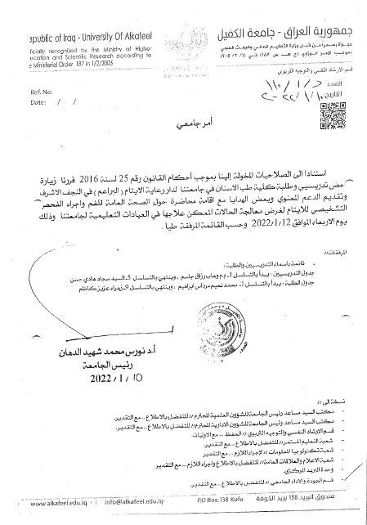

* Workshops and Training Programs: The university organizes workshops and training programs focused on entrepreneurship, business management, and sustainable practices. These programs equip aspiring business owners with the knowledge and skills needed to run successful projects, prioritizing social responsibility and environmental sustainability.

|  |  |
| --- | --- |
| The Volunteer Team of Awareness against Drugs Held its First Meeting at Alkafeel University | <https://en.alkafeel.edu.iq/news/details/1087> |
| Alkafeel University Holds a Workshop on the Emotional Intelligence | <https://en.alkafeel.edu.iq/news/details/1091> |
| A Workshop on "Administrative Communication" at Alkafeel University | <https://en.alkafeel.edu.iq/news/details/1103> |
| Alkafeel University Holds a Workshop on "Anger Management and Ways to Deal with Rebellious and Stubborn Personality" | <https://en.alkafeel.edu.iq/news/details/1107> |
| Alkafeel University holds a workshop on Factors Associated with Managing Emotions | <https://en.alkafeel.edu.iq/news/details/1117> |
| A Guide for Students' Enrollment at Alkafeel University | <https://en.alkafeel.edu.iq/news/details/1144> |
| How to Evaluate the University Performance: A Workshop at Alkafeel University for the Academic Year 2021-2022 | <https://en.alkafeel.edu.iq/news/details/1146> |
| Alkafeel University Workshop on Toxoplasma Disease | <https://en.alkafeel.edu.iq/news/details/1152> |
| A Workshop on "Al-Siraj Platform" at Alkafeel University | <https://en.alkafeel.edu.iq/news/details/1170> |
| A Workshop on Brucellosis at Alkafeel University | <https://en.alkafeel.edu.iq/news/details/1176> |
| To Promote SDG3: A Workshop on Diagnosing Intestinal Parasites at Alkafeel University | <https://en.alkafeel.edu.iq/news/details/1192> |
| Financial Grants in Organizations for Academics | <https://en.alkafeel.edu.iq/news/details/1206> |
| To Preserve the Cultural Heritage: Alkafeel University Holds a Workshop on the Arabic Language Integrity in Administrative Correspondence - Drawing of the Letter Hamza | <https://en.alkafeel.edu.iq/news/details/1223> |
| Suggestions for Sustainable Ecosystem: A Training Workshop on "Protein Purification" at Alkafeel University | <https://en.alkafeel.edu.iq/news/details/1230> |
| To Educate the Wider Community: Alkafeel University Holds a Workshop on "Cyber Security" | <https://en.alkafeel.edu.iq/news/details/1232> |
| Equality and Non-Discrimination in Election: A Workshop at Alkafeel University | <https://en.alkafeel.edu.iq/news/details/1234> |
| Seeking to Create Sustainable Classroom Environment: A Workshop on Body Language at Alkafeel University | <https://en.alkafeel.edu.iq/news/details/1238> |
| Adaptation to Climate Change: A workshop on "the Development of World System" at Alkafeel University | <https://en.alkafeel.edu.iq/news/details/1275> |
| Workshop on Flow Injection Analysis Technique at Alkafeel University | <https://en.alkafeel.edu.iq/news/details/1283> |
| A workshop at Alkafeel University on the Extraction of Essential Oil in a Lab | <https://en.alkafeel.edu.iq/news/details/1285> |
| Workshop at Alkafeel University on the role of international non-governmental organizations in implementing the rules of international humanitarian law | <https://en.alkafeel.edu.iq/news/details/1287> |
| Workshop entitled "The Authority of the Constitutional Judiciary in Monitoring Constitutional Amendments in Iraq: A Comparative Study" | <https://en.alkafeel.edu.iq/news/details/1330> |
| The Department of Medical and Health Laboratories organizes a workshop on "Epidemiology of Malaria in Iraq" | <https://en.alkafeel.edu.iq/news/details/1333> |
| Scientific workshop at the Faculty of Dentistry on "Gastroesophageal reflux disease" | <https://en.alkafeel.edu.iq/news/details/1347> |
| Workshop at the College of Law on "Administrative Detention of Persons in Iraqi Law" | <https://en.alkafeel.edu.iq/news/details/1374> |
| Alkafeel University holds a workshop on “Legal Regulation of the Right to Access Information in Iraq - A Comparative Study” | <https://en.alkafeel.edu.iq/news/details/1412> |
| Alkafeel University.. College of Health and Medical Technologies holds a training workshop on "Sample Collection, Preservation and Estimation" | <https://en.alkafeel.edu.iq/news/details/1458> |
| Conducting a Workshop at Department of Medical Laboratories on "How to Design Primers Used in PCR Technology ?” | <https://en.alkafeel.edu.iq/news/details/1460> |
| University of Alkafeel as Participant in Workshop on Social Phenomena | <https://en.alkafeel.edu.iq/news/details/1478> |
| A workshop at the University of Alkafeel on the relativity of the impact of civil judgments | <https://en.alkafeel.edu.iq/news/details/1484> |
| Najaf Al-Ashraf Health Directorate and Faculty of Medicine in a Complementary Training Workshop : "Aiding Critical Cases" | <https://en.alkafeel.edu.iq/news/details/1490> |
| The University of Alkafeel .. The Information Technology Department at the University of Alkafeel participated in the training workshop on the " Electronic Issuance Document Authenticity Verification System " | <https://en.alkafeel.edu.iq/news/details/1502> |
| The College of Medical and Health Technologies in a Workshop on "Liver Function Testing" | <https://en.alkafeel.edu.iq/news/details/1554> |
| Workshop on “ Drug Interactions Checker” website | <https://en.alkafeel.edu.iq/news/details/1556> |
| The College of Dentistry holds a scientific workshop on "How to use the drug interaction checker website" | <https://en.alkafeel.edu.iq/news/details/1569> |
| The College of Dentistry holds a scientific workshop on "Photography in Dentistry" | <https://en.alkafeel.edu.iq/news/details/1575> |
| Alkafeel University.. College of Pharmacy participates in the National Evaluators Training Workshop | <https://en.alkafeel.edu.iq/news/details/1584> |
| The College of Health and Medical Technologies organizes a workshop entitled "Malta Fever: Challenges and Obstacles" | <https://en.alkafeel.edu.iq/news/details/1692> |
| University of Alkafeel in a Visit to Nursing Home | <https://en.alkafeel.edu.iq/news/details/1543> |

* **Mentorship and Guidance Services:** Alkafeel University connects local entrepreneurs with experienced mentors and advisors who can guide them through the process of starting and running a business. These services help entrepreneurs overcome challenges, make informed decisions, and build resilient enterprises.

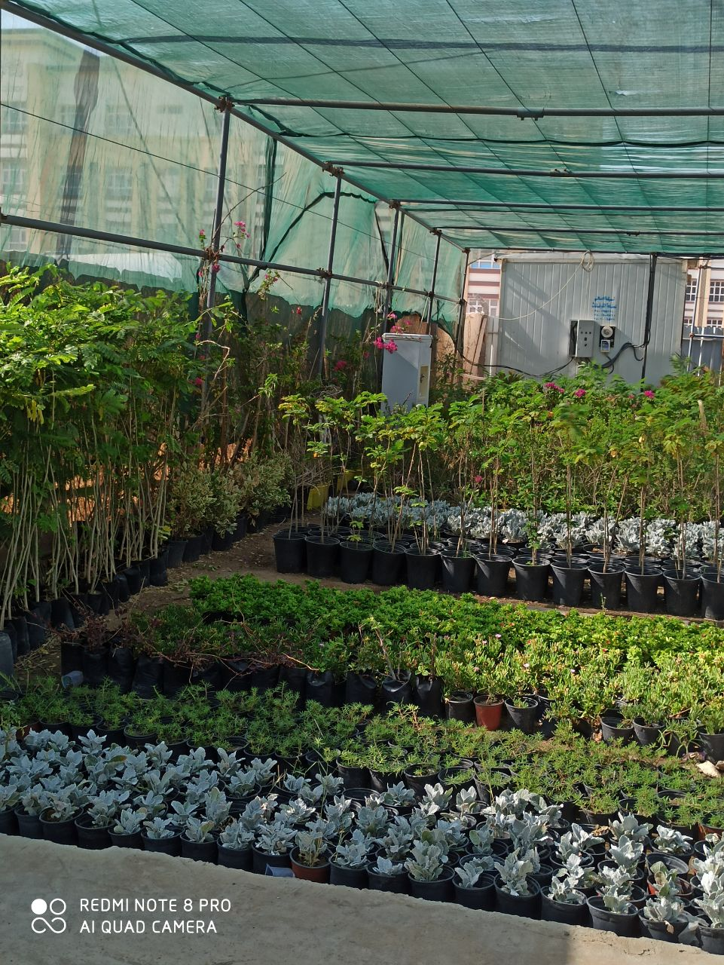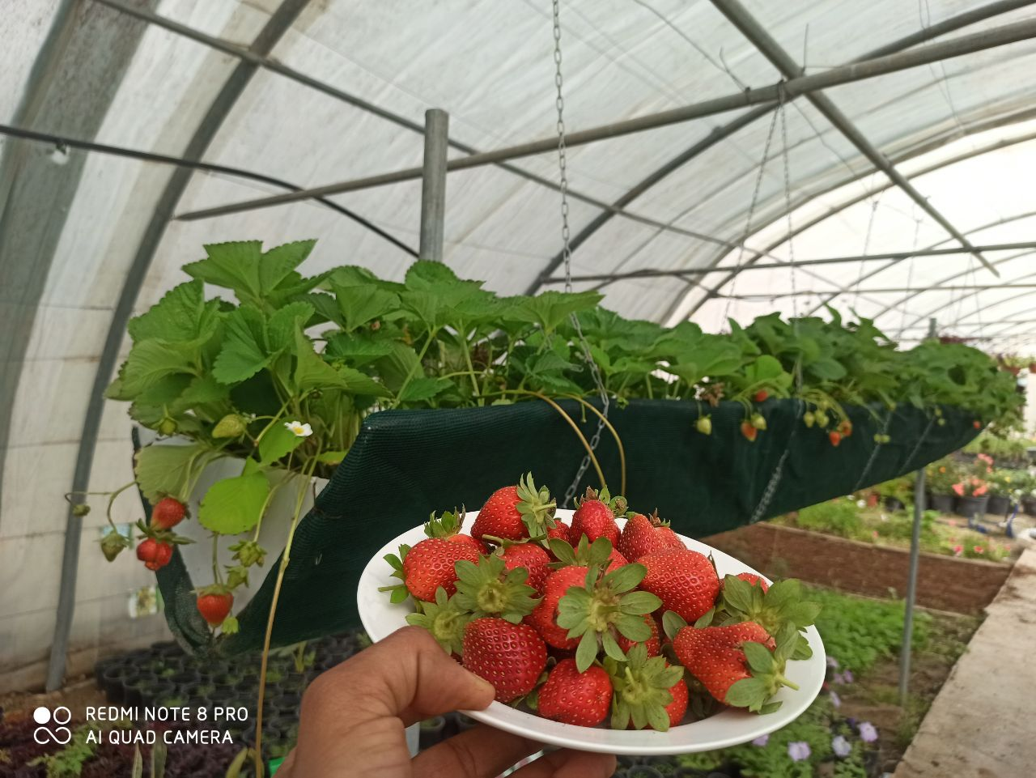

**University nursery Strawberry production**

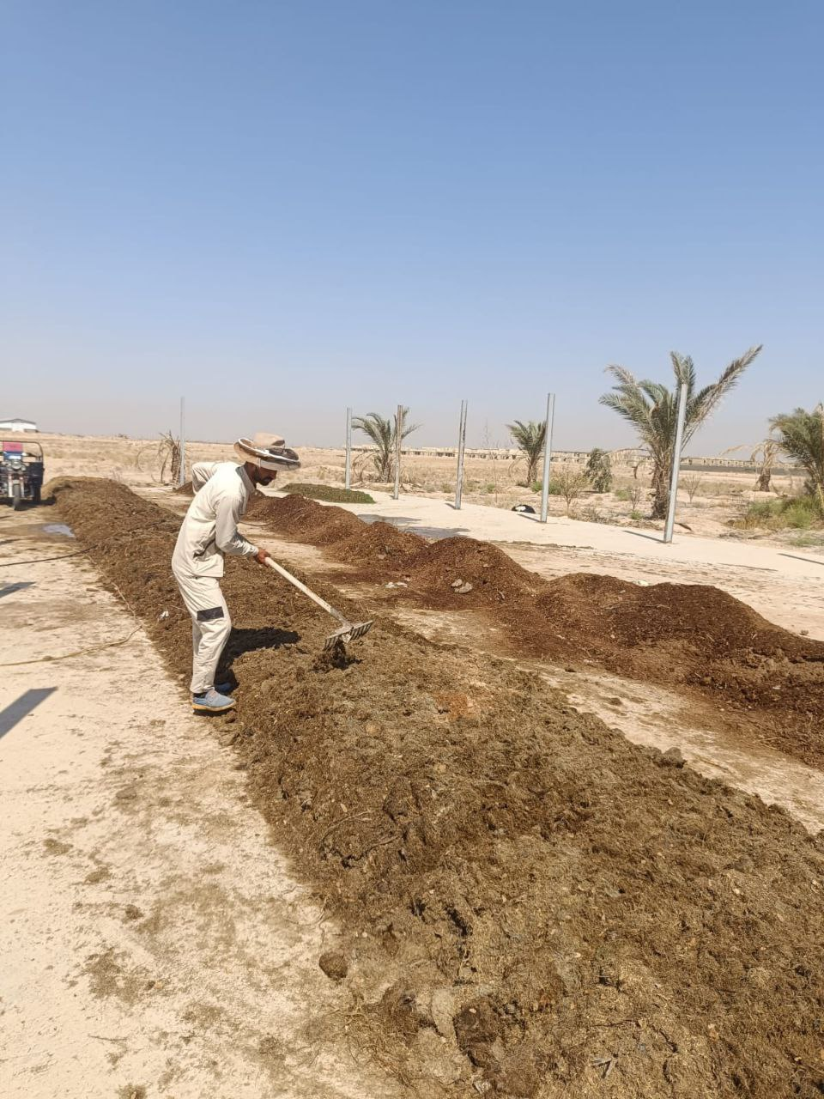

Location for preparing organic fertilizers from plant waste in gardens, where approximately 20 cubic meters of organic fertilizer are produced annually from the university's garden waste. According to the plan, we will import waste from neighboring areas to increase production



**Flow sensor**

**Irrigation control device**  
This device regulates the opening and closing of valves for gardens, including the operation and shutdown of irrigation pumps according to programmable schedules. These schedules can be set directly via the device's control panel or through a mobile application using remote communication technology.

Additionally, it can be connected to a rain sensor to prevent irrigation during rainfall or high humidity conditions, and a flow sensor to manage water flow through the valves.Its image is below

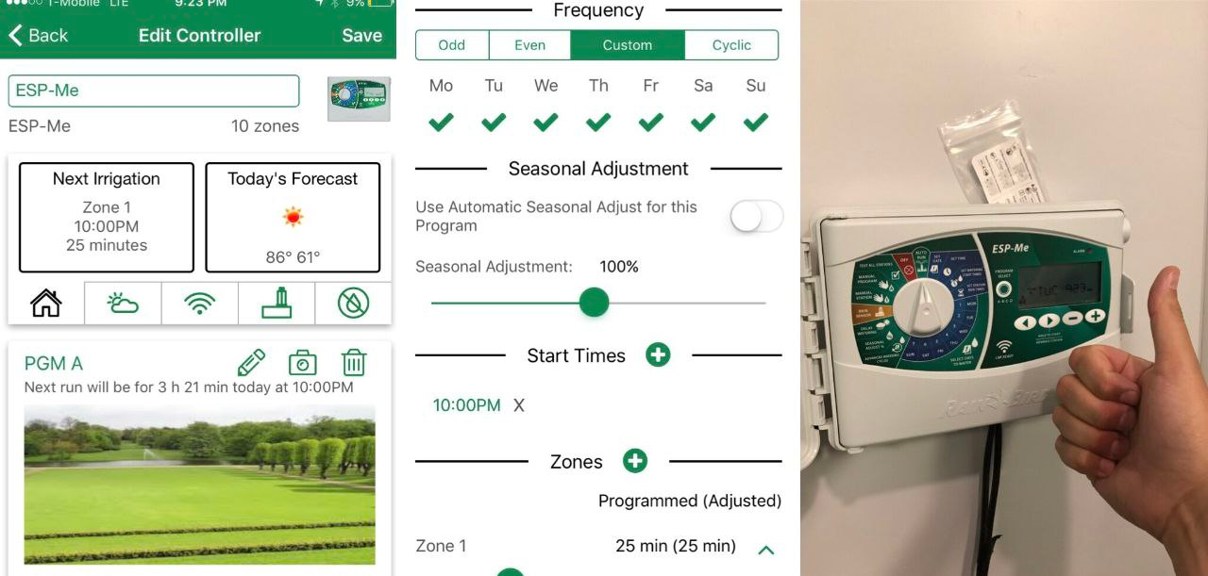

**Image of the application of the device on the phone**

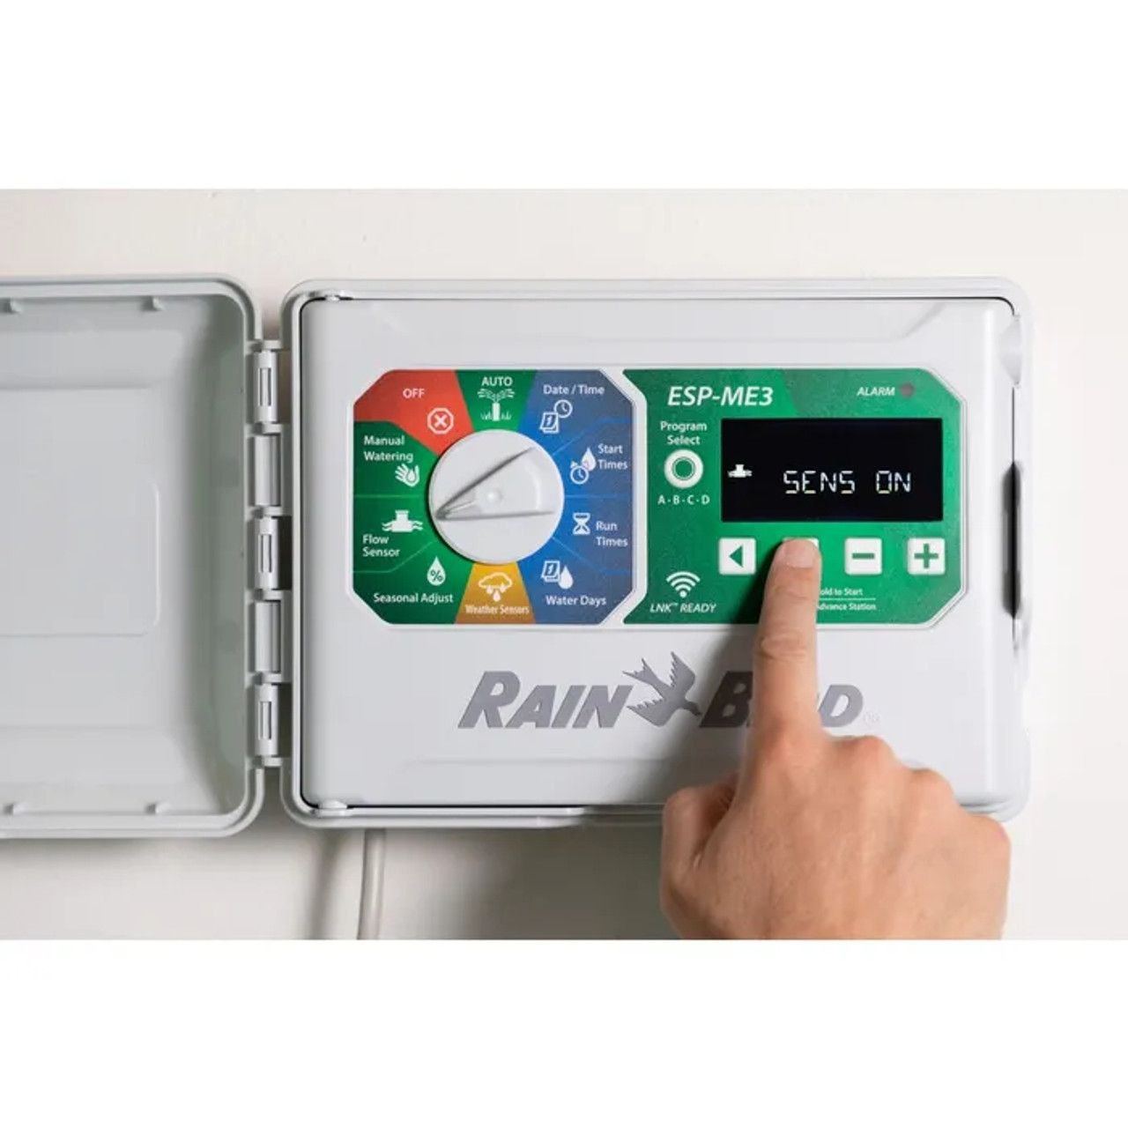

**Rain sensor**

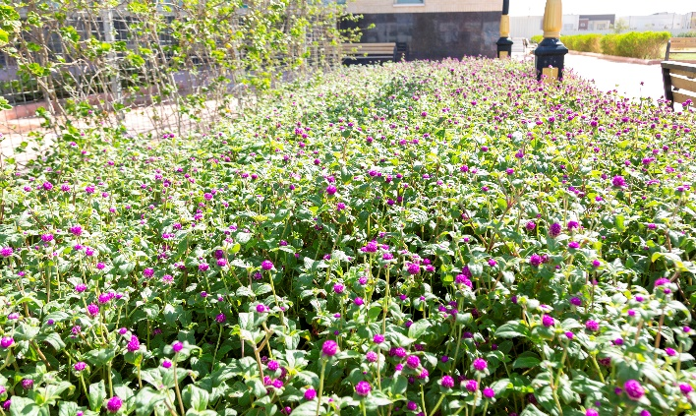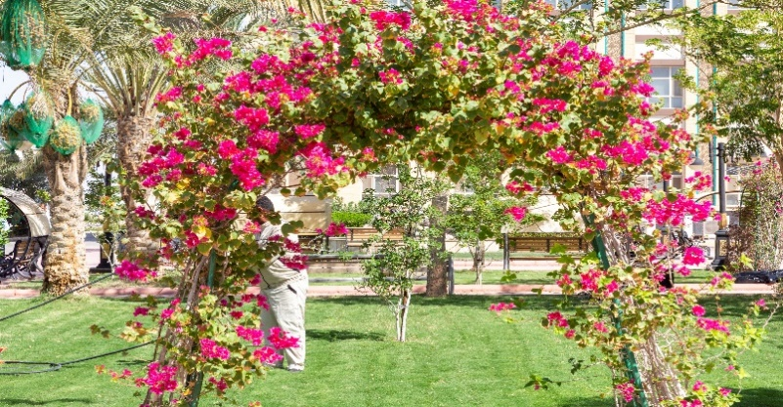

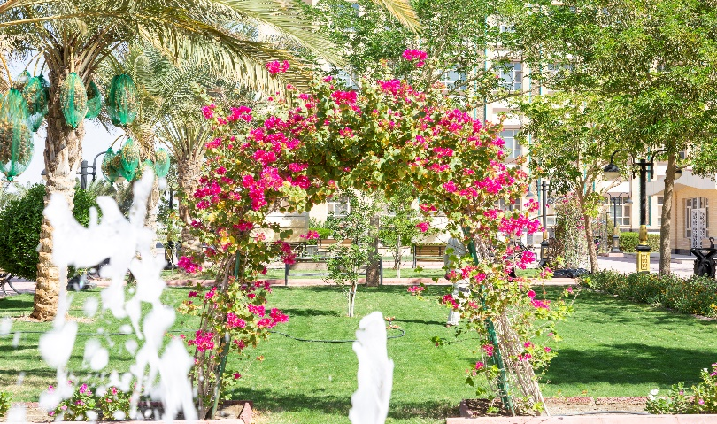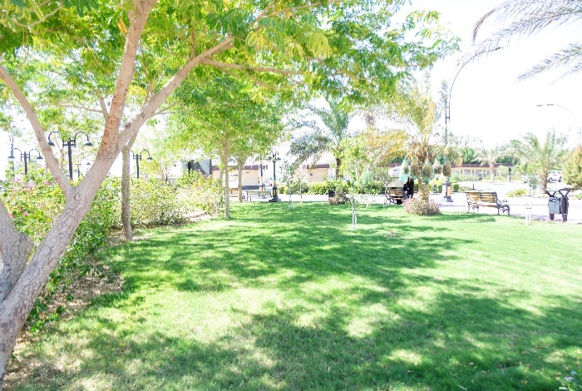

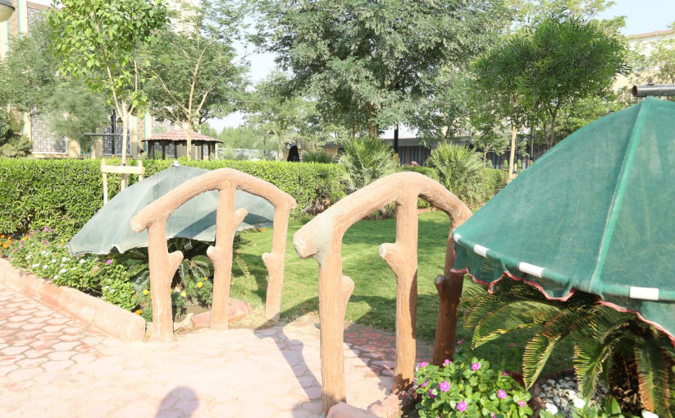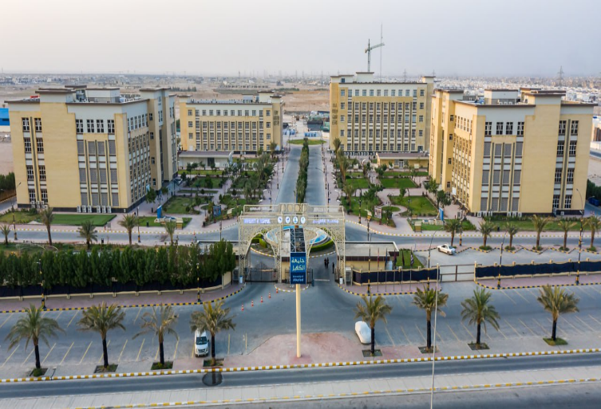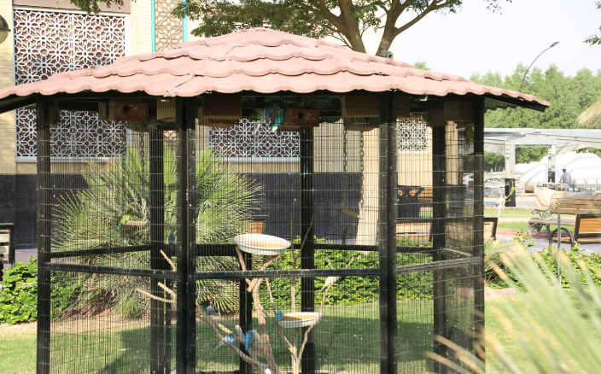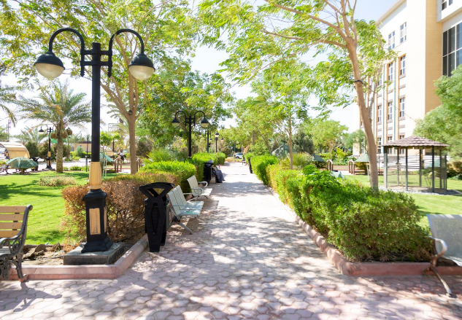

**Agricultural unit works**

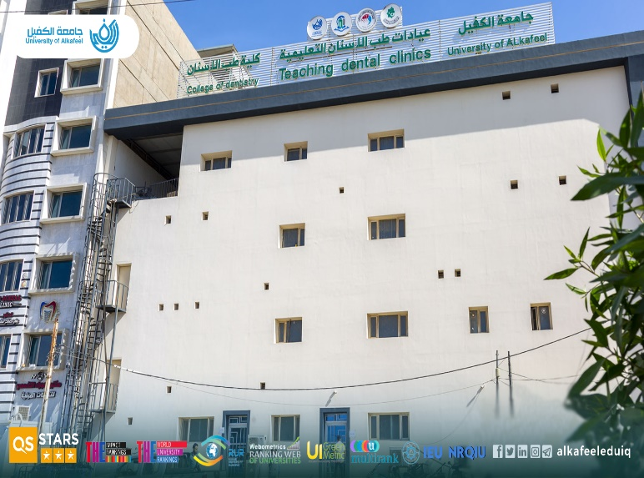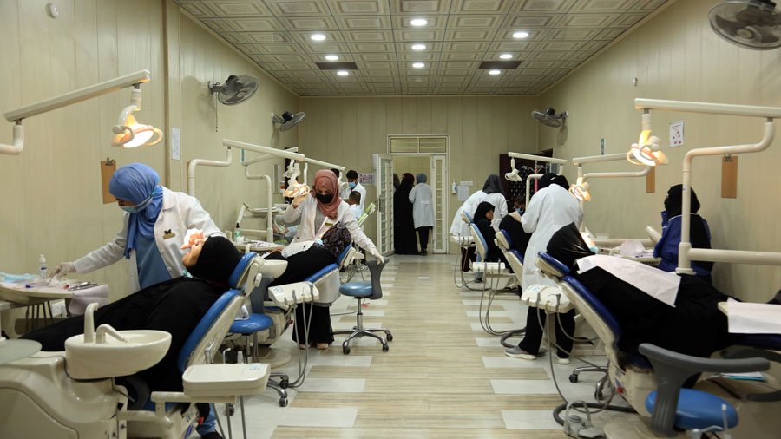**Encouraging Social Enterprises:** The university is committed to supporting businesses that address social issues and contribute to community well-being. This includes providing assistance to social enterprises focused on areas such as education, healthcare, environmental conservation, and poverty alleviation. By promoting socially sustainable businesses, the university helps create positive change within the local community.

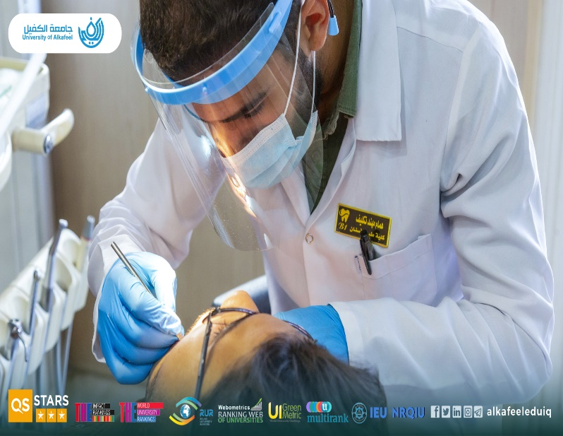 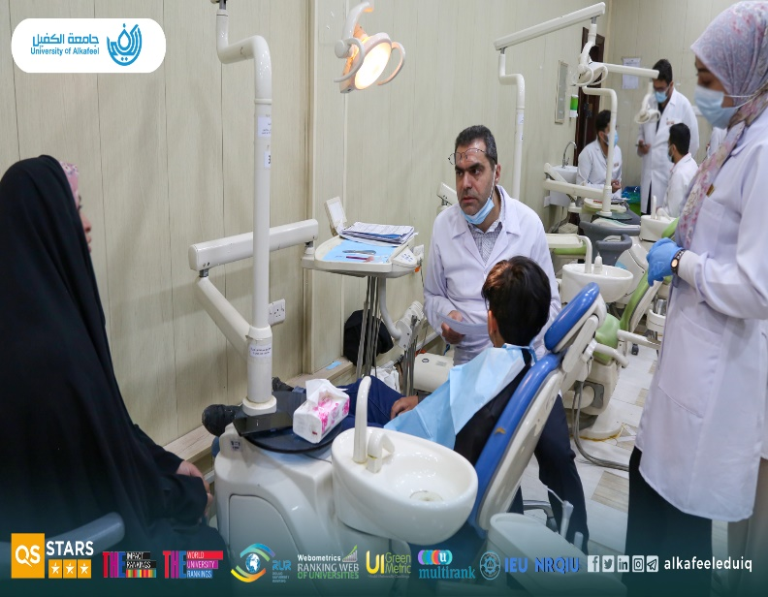

* **Networking Opportunities:** Alkafeel University hosts events that bring together local entrepreneurs, investors, industry experts, and community leaders. These networking opportunities allow startups to showcase their ideas, attract potential investors, and build partnerships that can lead to business growth.

Commitment to Sustainable Development: The university's efforts to support startups align with its broader commitment to sustainable development. By encouraging businesses that prioritize financial sustainability, social impact, and environmental responsibility, the university fosters a culture of responsible and sustainable growth.

* **Our Job Portal**

We have developed a dedicated job platform to connect graduates with career opportunities and provide ongoing support after graduation. Our goal is to empower graduates by advertising job openings and this is the link to it

[**https://alkafeel.edu.iq/careers/user/login**](https://alkafeel.edu.iq/careers/user/login)

**Closing of the second job fair activities at Alkafeel University**

**Link:** [**https://en.alkafeel.edu.iq/news/details/1513**](https://en.alkafeel.edu.iq/news/details/1513)



<https://youtu.be/PfflsFPVfQU>

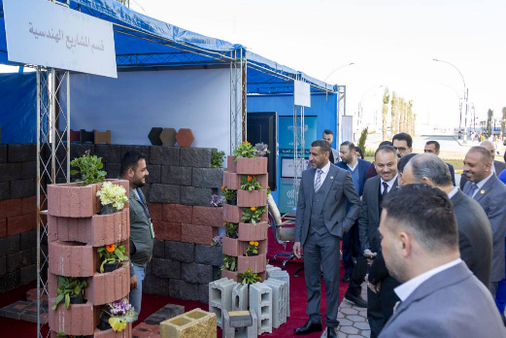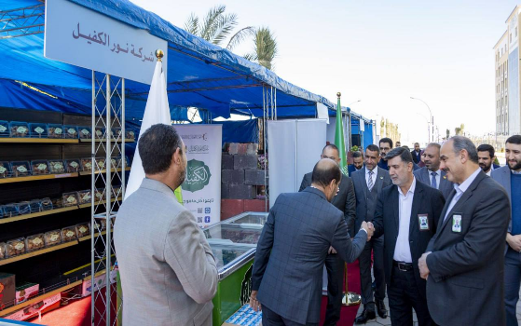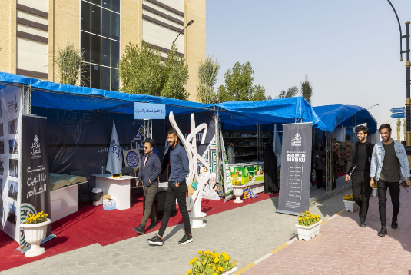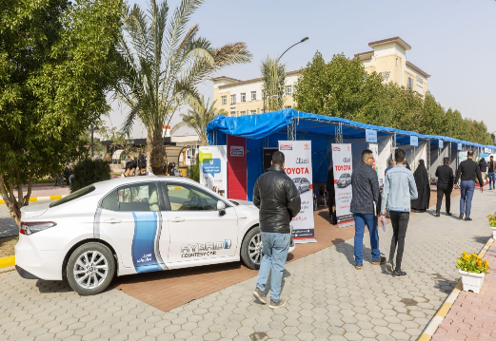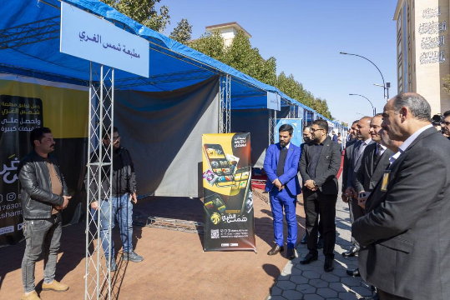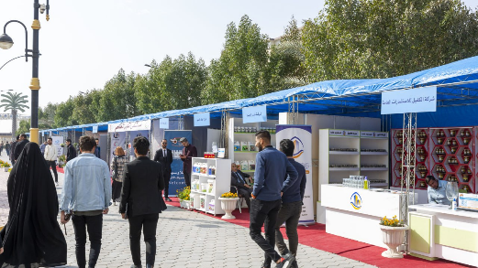

Job Fair - Day 3 2023/2/20